English Template Manuscript
Received: xxxxxxxxxxx | Revised: xxxxxxxxxxx | Accepted: xxxxxxxxxxx
English Title
(TH Sarabun PSK, 20 pt., Bold)
1 Enter 16 pt.
Name/Lastname^{1*}//Name/Lastname²//and//Name/Lastname²
(TH Sarabun PSK, 16 pt., Bold)
(In case there is more than one researcher, list the principal investigator's name first. If any co-researchers are affiliated with a different institution than the principal investigator, indicate their affiliation with a corresponding number)
1 Enter 16 pt.
Department, Faculty, University, Province, Country Postal code
(TH Sarabun PSK, 12 pt., Bold)
1 Enter 16 pt.
Abstract (TH Sarabun PSK, 16 pt., Bold)
1 Enter 16 pt.
(1 Tab) (TH Sarabun PSK, 16 pt.)
…………………………………………………………………………………………………………………..............................................................…
…………………………………………………………………………………………………………………………………………………………………………………………………………………………………………………………………………………………………………………………………………………………

1 Enter 8 / 10 pt.
Keywords:///……...,/……...,/……...,/……...,/……... (TH Sarabun PSK, 16 pt.,) 3-5 words

*Corresponding author: ……………@...........

Introduction (TH Sarabun PSK, 14 pt., Bold)
1 Enter 14 pt.
(1 Tab) (TH Sarabun PSK, 14 pt., Regular) .......................................................................................................................................
………………………………………………………………………………………………………………………………………………………………………………………………………………………………………………………………………………………………………………………………………………………………………………………………………………………………………………………………………………………………………………………………………
1 Enter 14 pt.
Materials and Methods/ Research Methodology (TH Sarabun PSK, 14 pt., Bold)
(If the work falls under the science category, use 'Materials and Methods.' If it falls under the category of social sciences, use 'Research Methodology.')
1 Enter 14 pt.
(1 Tab) (TH Sarabun PSK, 14 pt., Regular) ……………………………………………………………………………………………………….……………….
………………………………………………………………………………………………………………………..……………………………………….……………………………………………………………………………………………………………………………………………………………..…………….………………………………………………………………………………………………………………………………………………………………………………………
1 Enter 14 pt.
Results and Discussion (TH Sarabun PSK, 14 pt., Bold)
1 Enter 14 pt.
(1 Tab) (TH Sarabun PSK, 14 pt., Regular) ……...................................................................................................................................
………………………………………………………………………………………………………………………………………………………………..…………………………………………………………………………………………………………………………………………………………………………..………………………………………………………………………………………………………………………………………………………………………………………
1 Enter 14 pt.
Conclusion (TH Sarabun PSK, 16 pt., Bold)
1 Enter 14 pt.
(1 Tab) (TH Sarabun PSK, 14 pt., Regular)……….....................................................………………………………….……….……………..………
…………………………………………………………………………………………………………………………………………………..…………………………………………………………………………………………………………………………………………………………………………..……………………………………………………………………………………………………………………………………………………………………….………………………….. 1 Enter 14 pt.
Recommendations (TH Sarabun PSK, 14 pt., Bold)
1 Enter 14 pt.
(1 Tab) (TH Sarabun PSK, 14 pt.)………………….............................................…….……………………………………..…
……………………………………………………………………………………………………………………………………………………………...……………………………………………………………………………………………………………………………………………………………………..………………………………………………………………………………………………………………………………………………………
1 Enter 14 pt.
Acknowledgment (TH Sarabun PSK, 14 pt., Bold)
1 Enter 14 pt.
(1 Tab) (TH Sarabun PSK, 14 pt.)……………………………………………………………………………..........…………..….……
………………………………………………………………………………………………………………………………………………………………………………………………………………………………………………………………………………………………………………………………………………………………………………………………………………………………………………………………………………………………
1 Enter 14 pt.
References (TH Sarabun PSK, 14 pt., Bold)
1 Enter 14 pt.
(TH Sarabun PSK, 14 pt., Regular) ……………………………………………………………………………………
(1Tab)……………………………………………………………………………………………………
(TH Sarabun PSK, 14 pt.) ……………………………………………………………………………………
(1Tab)……………………………………………………………………………………………………
(TH Sarabun PSK, 14 pt.) ……………………………………………………………………………………
(1Tab)……………………………………………………………………………………………………
(TH Sarabun PSK, 14 pt.) ……………………………………………………………………………………
(1Tab)……………………………………………………………………………………………………
(APA 7th edition or American Psychological Association style)

*The maximum of the article is 8 - 15 pages

Authors must integrate tables, figures, and images within the main text. Formatting should adhere to the prescribed journal guidelines as specified below

Table/1(TH Sarabun PSK, 14 pt., Bold)//Description (TH Sarabun PSK, 14 pt., Regular)
1 Enter 8 pt.
No. | Place | Sample | Positive | % Positive
1 | Sriracha | 20 | 0 | 0
2 | Muang Chonburi | 25 | 8 | 32.00
3 | Phanat Nikhom | 41 | 9 | 21.95
4 | Koh Sri-chang | 33 | 6 | 18.18
Total |  | 119 | 23 | 19.33
1 Enter 5 pt.
Note: Description (TH Sarabun PSK, 12 pt., Regular)…………………………………………………………………………
1 Enter 14 pt.

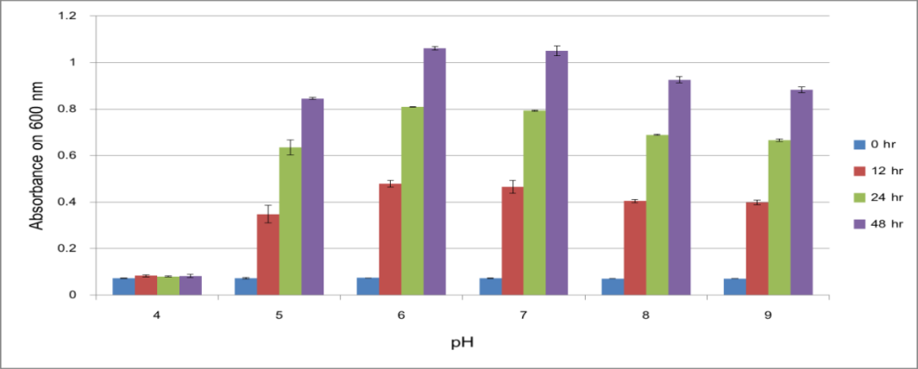
1 Enter 14 pt.

Figure/1 (TH Sarabun PSK, 14 pt., Bold)// Description (TH Sarabun PSK, 14 pt., Regular)……………………..
1 Enter 14 pt.

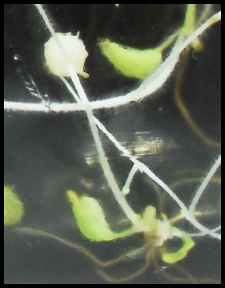
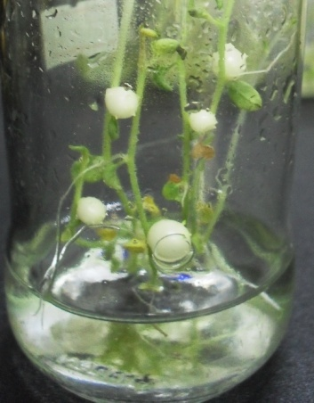
A
B
1 Enter 14 pt.
Figure/1 (TH Sarabun PSK, 14 pt., Bold)// Description (TH Sarabun PSK, 14 pt., Regular)…………………
*Resolution of pictures no less than 300 DPI

